**1.INTRODUCTION**

An Ecommerce website is an information technology method in which trader, businesses/distributor/marketers can sell products/services and the customer can purchase on that website electronically by using internet on the mobile and computer.It means an e-commerce website is an online shop. E means electronic. Commerce means business. Website means the assembly of HTML web pages and that is fashioned to market/sell information/product/Services.In a superior perspective, every website on the internet is the Ecommerce Website .Shopping has long been considered a recreational activity by many. Shopping online is no exception. The goal of this application is to develop a web based interface for online retailers. The system would be easy to use and hence make the shopping experience pleasant for the users. The goal of this application is

• To develop an easy to use web based interface where users can search for products, view a complete description of the products and order the products.

• A search engine that provides an easy and convenient way to search for products specific to their needs. The search engine would list a set of products based on the search term and the user can further filter the list based on various parameters.

• Drag and Drop feature which would allow the users to add a product to or remove a product from the shopping cart by dragging the product in to the shopping cart or out of the shopping cart.

• A user can view the complete specification of the product along with various images and also view the customer reviews of the product. They can also write their own reviews.

**1.1. OBJECTIVES AND SCOPE OF THE PROJECT**

**OBJECTIVES:**

The objective of the project is to make an application in android platform to purchase items in an existing shop. In order to build such an application complete web support need to be provided. A complete and efficient web application which can provide the online shopping experience is the basic objective of the project. The web application can be implemented in the form of an android application with web view.

**SCOPE:**

• The current system can be extended to allow the users to create accounts and save products in to wish list.

• The users could subscribe for price alerts which would enable them to receive messages when price for products fall below a particular level.

• The current system is confined only to the shopping cart process. It can be extended to have a easy to use check out process.

• Users can have multiple shipping and billing information saved. During checkout they can use the drag and drop feature to select shipping and billing information.

**1.2. LITERATURE SURVEY**

The history of Online men shopping carts began immediately after the World Wide Web, or WWW, became a major medium to communicate information around the world. shopping-cart applications allow consumers to buy goods or services directly over the internet using a web browser. This online shopping evokes the business-to-consumer (B2C) process where a consumer buys directly from the business. The process where a business buys from another business is called a business-to-business (B2B) process. The best examples of shoppingcart applications using B2B process are eBay and Amazon, both of which were launched in 1995. At present, most users of these online shopping-cart applications are people who have higher levels of education, have exposure to technological advancements, and are in a better income group. Such users develop a positive attitude towards these convenient shopping techniques. According to a study in December 2011, Equation Research surveyed 1,500 online shoppers and found that 87% of tablet owners made online transactions during the early Christmas shopping season. Building a new successful shopping cart is simple because of high competition in the market, and the designer of a shopping-cart application must consider the information load, complexity, and novelty. Complexity refers to the number of features available on the shopping cart and the levels of marketing, whereas novelty involves the unexpected or unfamiliar aspects of the site. A designer must also consider the consumers’ needs and expectations. A user- 4 friendly design is very critical to the success of any shopping-cart application because, unlike physical stores, consumers at online stores come from all ages, genders, and cultures.

**2.SYSTEM ANALYSIS**

**2.1 PROBLEM DEFINITION**

Problem Definition This projects aims to develop an online shopping for customers with the goal so that it is very easy to shop your loved things from a extensive number of online shopping sites available on the web. With the help of this you can carry out an online shopping from your home. Here is no compelling reason to go to the crowed stores or shopping centers during festival seasons. You simpy require a PC or a laptop and one important payment sending option to shop online.To get to this online shopping system all the customers will need to have a email and password to login and proceed your shopping . The login credentials for an online shopping system are under high security and nobody will have the capacity to crack it easily. Upon successful login the customers can purchase a wide range of things such as mobiles, books, apparel, jewellery, infant care, gifts, tools, etc. can be dispatched using online shopping system. Not justthese, you can also purchase from outside nations by few clicks on your mouse. And of course you will get your requested ordered items at your door step. It is simple. You will pick your favourite items from variety of online shopping sites looking at cost and quality. No need to go physical shops with this you will have more time to spend with your family.It Just need a computer and a payment making options like net banking, credit card, debit card or paypal.Almost a wide range of things can be brought through online shopping system.You can purchase goods from foreign places from your bedroom and you will get your goods at your home.It is extremely secure. Customer service is accessible.

* 1. **EXISTING SYSTEM**

The present scenario for shopping is to visit the shops and market manually and then from the available product list one needs to choose the item he or she wants and then pay for the same item mainly in cash mode is done, as not every society is well educated and aware to use net banking or card modes or wallets etc. This system is not much user-friendly as one needs to go to the market physically and then select items only from the available list. So mostly it is difficult to get the product as per our desire. Description About the products is less available and are mostly verbal only. For this type of shopping, one needs to have an ample amount of free time.

It is less user-friendly.

User must go to shop and select products.

It is difficult to identify the required product.

Description of the product limited.

It is a time consuming process

Not in reach of distant users

* **DISADVANTAGES:**

1. Time consuming.
2. Risk taking in a non-controlled environment.
3. Possible conflict with user.
4. Incomplete project can be a major issue.
5. Group conflicts.
   1. **PROPOSED SYSTEM**

In the proposed system customer need not go to the shop for buying the products. He can order the product he wish to buy through the application in his Smartphone. The shop owner will be admin of the system. Shop owner can appoint moderators who will help owner in managing the customers and product orders. The system also recommends a home delivery system for the purchased products. People in large number are doing online shopping today, and it is not only because it is convenient as one can shop from home, but also because there is an ample number of varieties available, with a high competition of prices, and also it is easy to navigate for searching regarding any particular item. For sellers, their product has access to the World-Wide market, which also increases the number of customers and enhances customer relationships. Also, web stores are a means for small-scale companies to launch their products at the global level. The main objective of this project is to develop a web-oriented application that can provide an online shopping feature to users.

* **ADVANTAGES:**

1. Working with an actual end-user.
2. Improves communications skills: interviewing, problem solving, conflict resolution, and oral and written communication.
3. Projects have “real” meaning, not artificially invented.
4. Promotes industry/university relationships.
5. Potential employee source.

**2.4 FEASIBILITY STUDY**

**2.4.1 ECONOMICAL FEASIBILITY**

This study is carried out to check the economic impact that the system will have on the organization. The amount of fund that the company can pour into the research and development of the system is limited. The expenditures must be justified. Thus the developed system as well within the budget and this was achieved because most of the technologies used are freely available. Only the customized products had to be purchased.

**2.4.2 OPERATIONAL FEASIBILITY**

Operational feasibility is the measure of how well a proposed system solves the problems, and takes advantage of the opportunities identified during scope definition and how it satisfies the requirements identified in the requirements analysis phase of system development.[[6]](https://en.wikipedia.org/wiki/Feasibility_study#cite_note-SAD-Global_Enterprise-6)

The operational feasibility assessment focuses on the degree to which the proposed development projects fits in with the existing business environment and objectives with regard to development schedule, delivery date, [corporate culture](https://en.wikipedia.org/wiki/Corporate_culture) and existing business processes.

To ensure success, desired operational outcomes must be imparted during design and development. These include such design-dependent parameters as reliability, maintainability, supportability, usability, reducibility, disposability, sustainability, affordability and others. These parameters are required to be considered at the early stages of design if desired operational behaviours are to be realized. A system design and development requires appropriate and timely application of engineering and management efforts to meet the previously mentioned parameters. A system may serve its intended purpose most effectively when its technical and operating characteristics are engineered into the design. Therefore, operational feasibility is a critical aspect of systems engineering that needs to be an integral part of the early design phases.

**2.4.3 TECHNICAL FEASIBILITY**

This study is carried out to check the technical feasibility, that is, the technical requirements of the system. Any system developed must not have a high demand on the available technical resources. This will lead to high demands on the available technical resources. This will lead to high demands being placed on the client. The developed system must have a modest requirement, as only minimal or null changes are required for implementing this system.

**2.4.4 ORGANIZATION FEASIBILITY**

To define the legal and corporate structure of the business. An Organizational Feasibility Study may also include professional background information about the founders and principals of the business and what skills they can contribute to the business.

**2.4.5. ENVIRONMENTAL FEASIBILITY**

The aspect of study is to check the level of acceptance of the system by the user. This includes the process of training the user to use the system efficiently. The user must not feel threatened by the system, instead must accept it as a necessity. The level of acceptance by the users solely depends on the methods that are employed to educate the user about the system and to make him familiar with it. His level of confidence must be raised so that he is also able to make some constructive criticism, which is welcomed, as he is the final user of the system.

**3.SOFTWARE REQUIREMENTS SPECIFICATIONS**

To use this web application the system requires interent connectivity and a web browser, here bellow are the Hardware and Software requirements as follows :

**3.1 HARDWARE AND SOFTWARE REQUIREMENTS**

**HARDWARE SPECIFICATION:**

* Any operating system (Windows, Linux, MAC, etc..).
* Ram Must be at least 512 mb.
* The System Should Has Internet Connection.
* Modem, Dongel, Wifi can be used for internet connection.

**SOFTWARE SPECIFICATION:**

* Google Chrome/Firefox is recomended for this project for better performance and a good interaction with the end user.
* XAMPP Server, WAMP Server, etc(any one)
* Browsers and other Internet clients access to the web applications.
* The operating system should support HTTPS (Hyper Text Transfer Protocol Secured) protocols.
* The operating system should support TCP (Transfer Control Protocol).
* The operating system should support IP (Internet Protocol).

**3.2 DESCRIPTION ABOUT THE TOOLS:**

**3.2.1 FRONT END:**

This Web application is developed with html,css and javascript as front end, and the front end is userfriendly and easy to understand for any user.

### HTML (Hyper Text Markup Language) :

HTML is a markup language used by the browser to manipulate text, images, and other content, in order to display it in the required format. HTML was created by Tim Berners-Lee in 1991.

HTML stands for HyperText Markup Language. It is used to design web pages using a markup language. HTML is the combination of Hypertext and Markup language. Hypertext defines the link between the web pages. A markup language is used to define the text document within tag which defines the structure of web pages.

### CSS (Cascading Style Sheets) :

CSS (Cascading Style Sheets) is a stylesheet language used to design the webpage to make it attractive. The reason for using this is to simplify the process of making web pages presentable. It allows you to apply styles to web pages. More importantly, it enables you to do this independent of the HTML that makes up each web page.

### JAVA-SCRIPT :

JavaScript is the world most popular lightweight, interpreted compiled programming language. It is also known as scripting language for web pages. It is well-known for the development of web pages, many non-browser environments also use it. JavaScript can be used for Client-side developments as well as Server-side developments

**3.2.2 Back END:**

* **PHP**
* **MySQL**

We used Php Program for backend and MySQL do calculation and processing in our web application, and to connect it with database to get data, post data, delete data, and modify data.

### PHP (Hypertext Preprocessor)

PHP is an open-source, interpreted, and object-oriented scripting language that can be executed at the server-side. PHP is well suited for web development. Therefore, it is used to develop web applications

**MySQL (My Structured Query Language)**

* MySQL is a widely used relational database management system (RDBMS).
* MySQL is free and open-source.
* MySQL is ideal for both small and large applications.

**INTRODUCTION TO BOOTSTRAP FRAMEWORK**

**BOOTSTRAP FRAMEWORK**

* Bootstrap is the most popular HTML, CSS and JavaScript framework for developing a responsive and mobile friendly website.
* It is absolutely free to download and use.
* It is a front-end framework used for easier and faster web development.
* It includes HTML and CSS based design templates for typography, forms, buttons, tables, navigation, modals, image carousels and many others.
* It can also use JavaScript plug-ins.
* It facilitates you to create responsive designs.

### PHP MY ADMIN (Database) :

phpMyAdmin is the most trusted and user-friendly database managers and mostly used for web-based applications or programs. In the following article, we will be learning about the importance of the phpMyAdmin tool in the web world.

**Web Browser:** You need a web browser interface to run the tool.

**Apache Web server:** You need a web server to store phpMyAdmin files.

**MySQL or MariaDB Database:** You need a database to manage application data.

### Few Feature :

* Manages all user level permissions
* Using Django Framework Models the tables are created and also the data can be added, updated, or deleted.
* It also provide ways to import, export and load text file data.
* It is very flexible with different operating system.
* It can control several servers at the same time.

.

**4.SYSTEM DESIGNS:**

**4.1 CLASS DIAGRAM**

 which shows a domain model for online shopping. The purpose of the diagram is to introduce some common terms, "dictionary" for online shopping - Customer, Web User, Account, Shopping Cart, Product, Order, Payment, etc. and relationships between. It could be used as a common ground between business analysts and software developers.

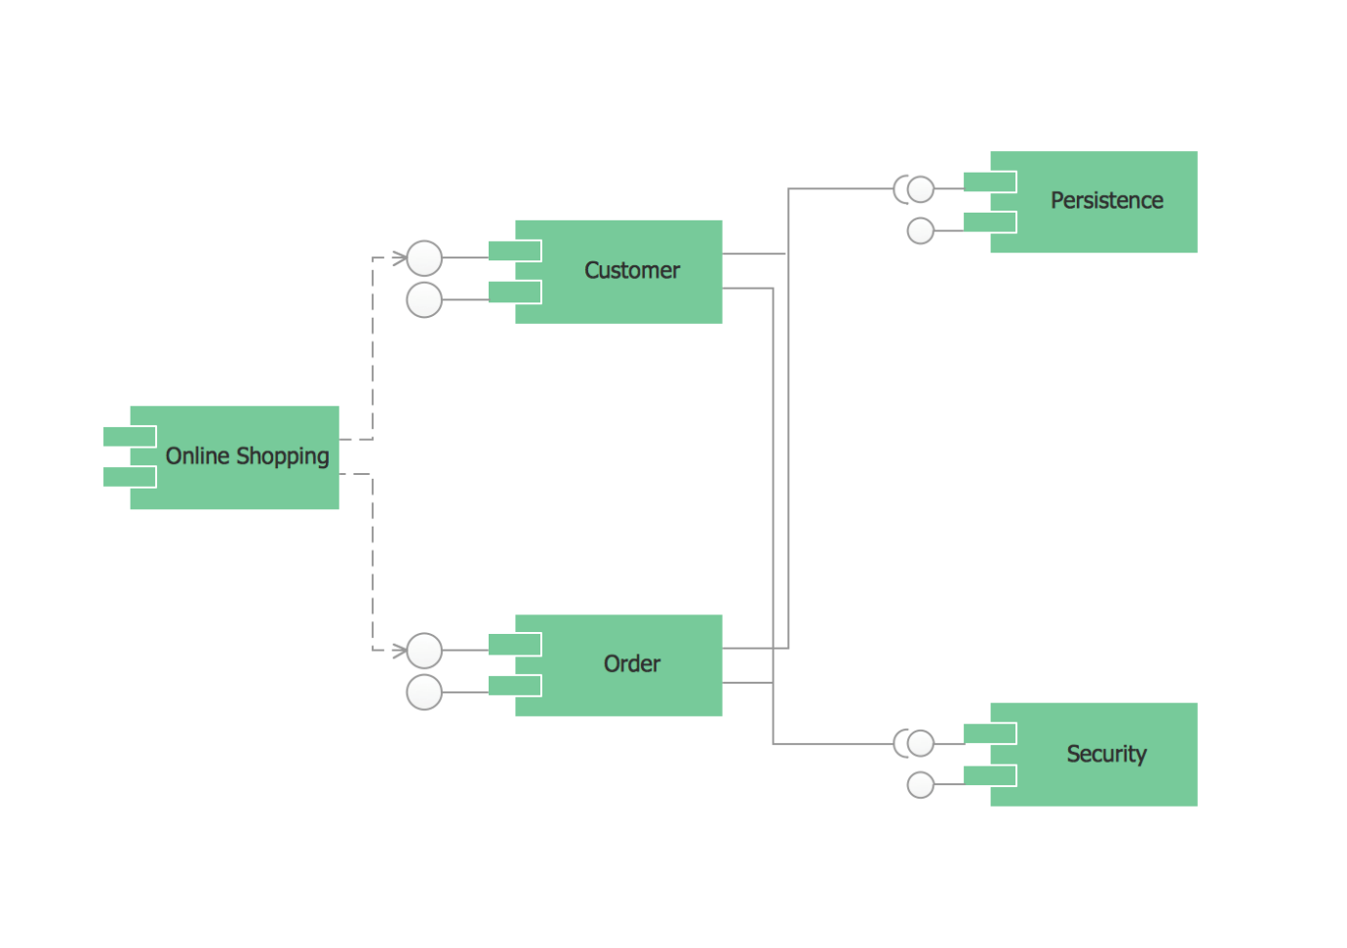

**Fig: Class Diagram**

**4.2 SEQUENCE DIAGRAM**

Universal Modeling Language (**UML**) diagrams are known as sequence diagrams. They’re used to demonstrate how different objects in a system interact over time. A sequence diagram aids a system’s designer in visualizing and comprehending the sequence in which these interactions take place. This makes it easy to spot possible issues and improve the way things work.

The sequence diagram depicts the sequence of events in the system from top to bottom. The objects are named rectangles at the top and bottom of the diagram, with a lifeline down the entire length of the diagram. Interactions between objects are represented by horizontal arrows pointing left or right. These are the messages that are passed between the objects.

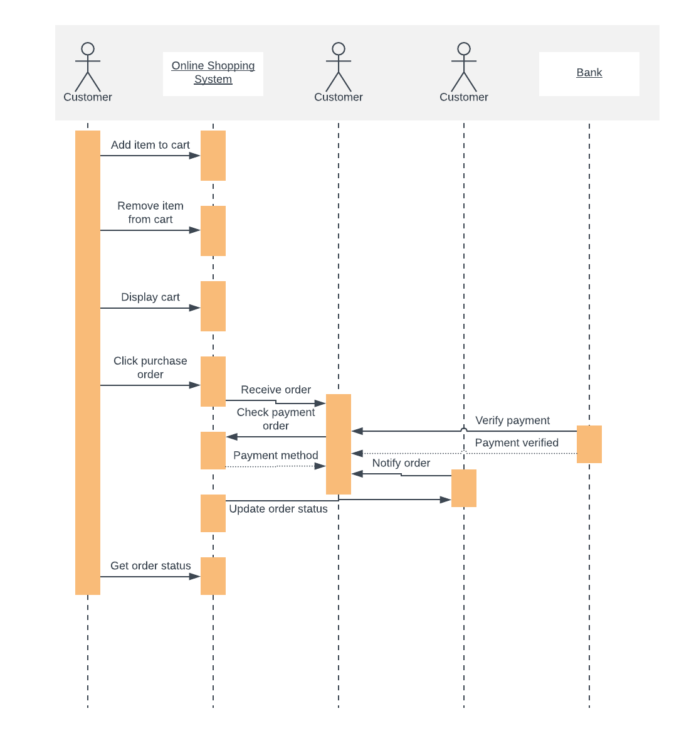

**Fig: Sequence Diagram**

**4.3 USE CASE DIAGRAM**

The system’s use case shows the user a detailed view of the system and how the actors would interact with each other and with the system. The explanation for each use case is then provided below the system use case for the administrator (Figure 1) and the user (Figure 2), helping the user to understand who are the actors areas as well as giving the description for each use case along with its pre- and post-conditions that should be satisfied once the use case is implemented in the software

**Figure 1** demonstrates the use case of for an administrator where he or she has access to the application. The administrator can access the home page, select a category, or add/delete items to/from the cart.

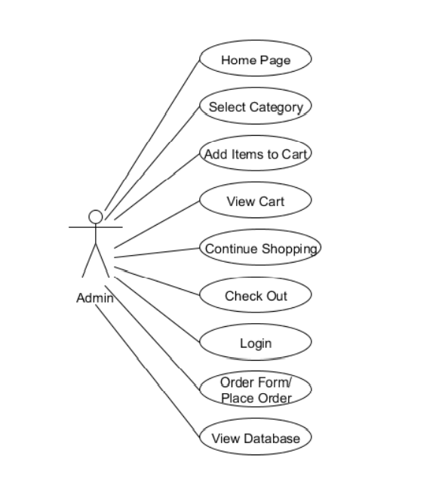

**Fig: Use-Case Diagram: Admin**

**Figure 2** demonstrates the use case for users where they have access to the online shopping-cart application. They can access the home page, select a category, add/delete items to/from the cart, view the shopping cart, and decide to either continue shopping or check out. They are required to go through the user-authentication form (login) which would only allow them to place an order for the items they selected.

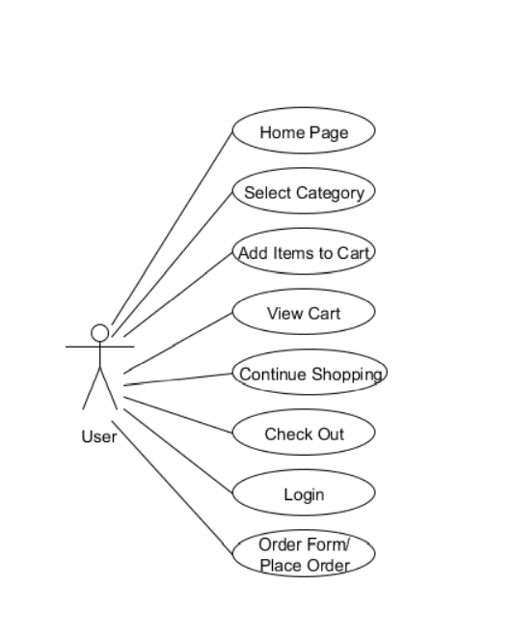

**Fig: Use-Case Diagram: User**

**4.4 DATA FLOW DIAGRAM**

A data flow diagram is graphical tool used to describe and analyze movement of data through a system. These are the central tool and the basis from which the other components are developed. The transformation of data from input to output, through processed, may be described logically and independently of physical components associated with the system. These are known as the logical data flow diagrams.

The physical data flow diagrams show the actual implements and movement of data between people, departments and workstations. A full description of a system actually consists of a set of data flow diagrams. Using two familiar notations Yourdon, Gane and Sarson notation develops the data flow diagrams. Each component in a DFD is labeled with a descriptive name. Process is further identified with a number that will be used for identification purpose.

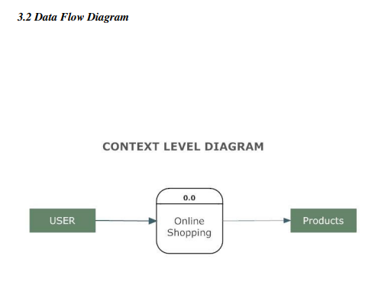

**Fig: Data Flow Diagram**

**DFD SYMBOLS:**

In the DFD, there are four symbols

1. A square defines a source(originator) or destination of system data
2. An arrow identifies data flow. It is the pipeline through which the information flows
3. A circle or a bubble represents a process that transforms incoming data flow into outgoing data flows.
4. An open rectangle is a data store, data at rest or a temporary repository of data

Process that transforms data flow.

Source or Destination of data

Data flow

Data Store

**ENTITY RELATIONSHIP DIAGRAM**

Attributes in ER diagrams are usually modelled as an oval with the name of the attribute, linked to the entity or relationship that contains the attribute. Within the [relational model](http://en.wikipedia.org/wiki/Relational_model) the final step can generally be broken down into two further steps that of determining the grouping of information within the system,

Generally determining what are the basic objects about which information is being stored, and then determining the relationships between these groups of information, or objects. This step is not necessary with an [Object database](http://en.wikipedia.org/wiki/Object_database).

1. **Entity:** A data entity is anything real or abstract about which we want to store data.
2. **Relationship**: A data relationship is a natural association that exists between one or more entities. Cardinality defines the number of occurrences of one entity for a single occurrence of the related entity.
3. **Attribute:** A data attribute is a characteristic common to all or most instances of a particular entity. An attribute or combination of attributes that uniquely identifies one and only instance of an entity is called a primary key.
4. **Degree of Relationship:** Is the number of entities associated with the relationship.
5. **Connectivity and Cardinality:** The connectivity of relationship describes the mapping of associated entity instances in the relationship.

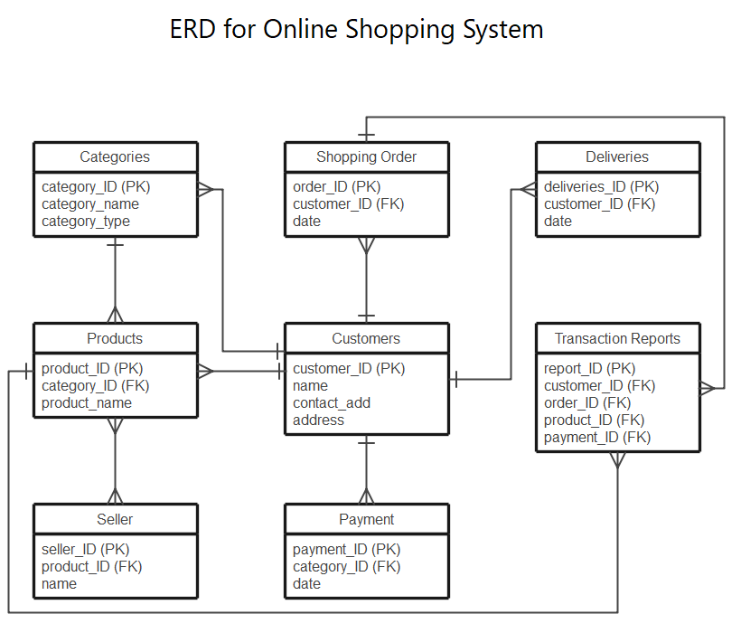

**5.SYSTEM IMPLEMENTATION**

**5.1 SCREEN SHOTS:**

**HOME PAGE**

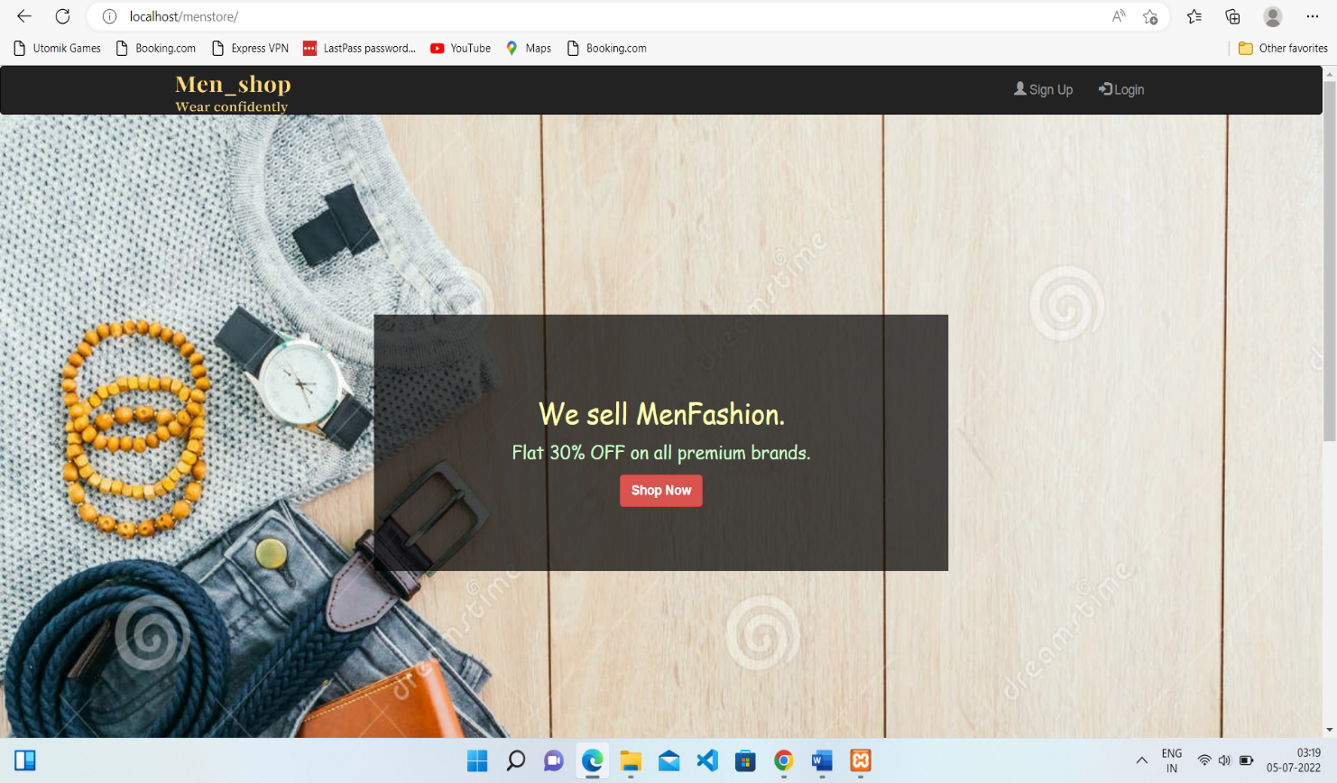

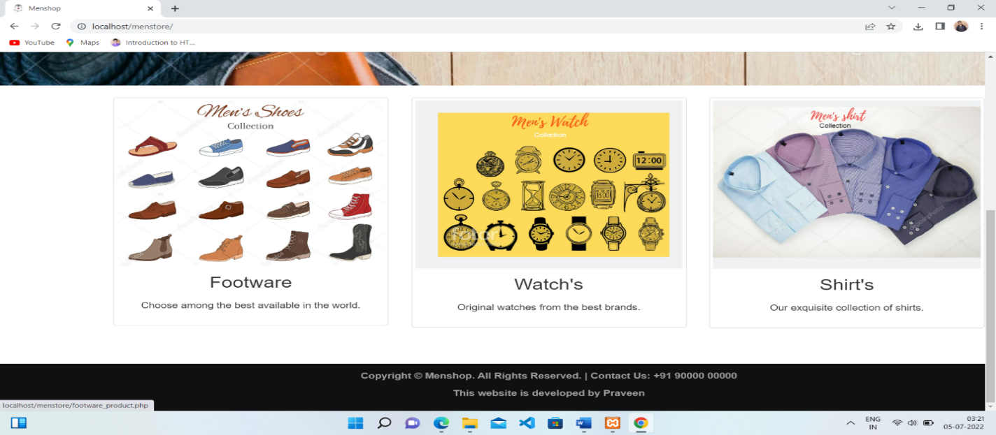

**SIGNUP PAGE**

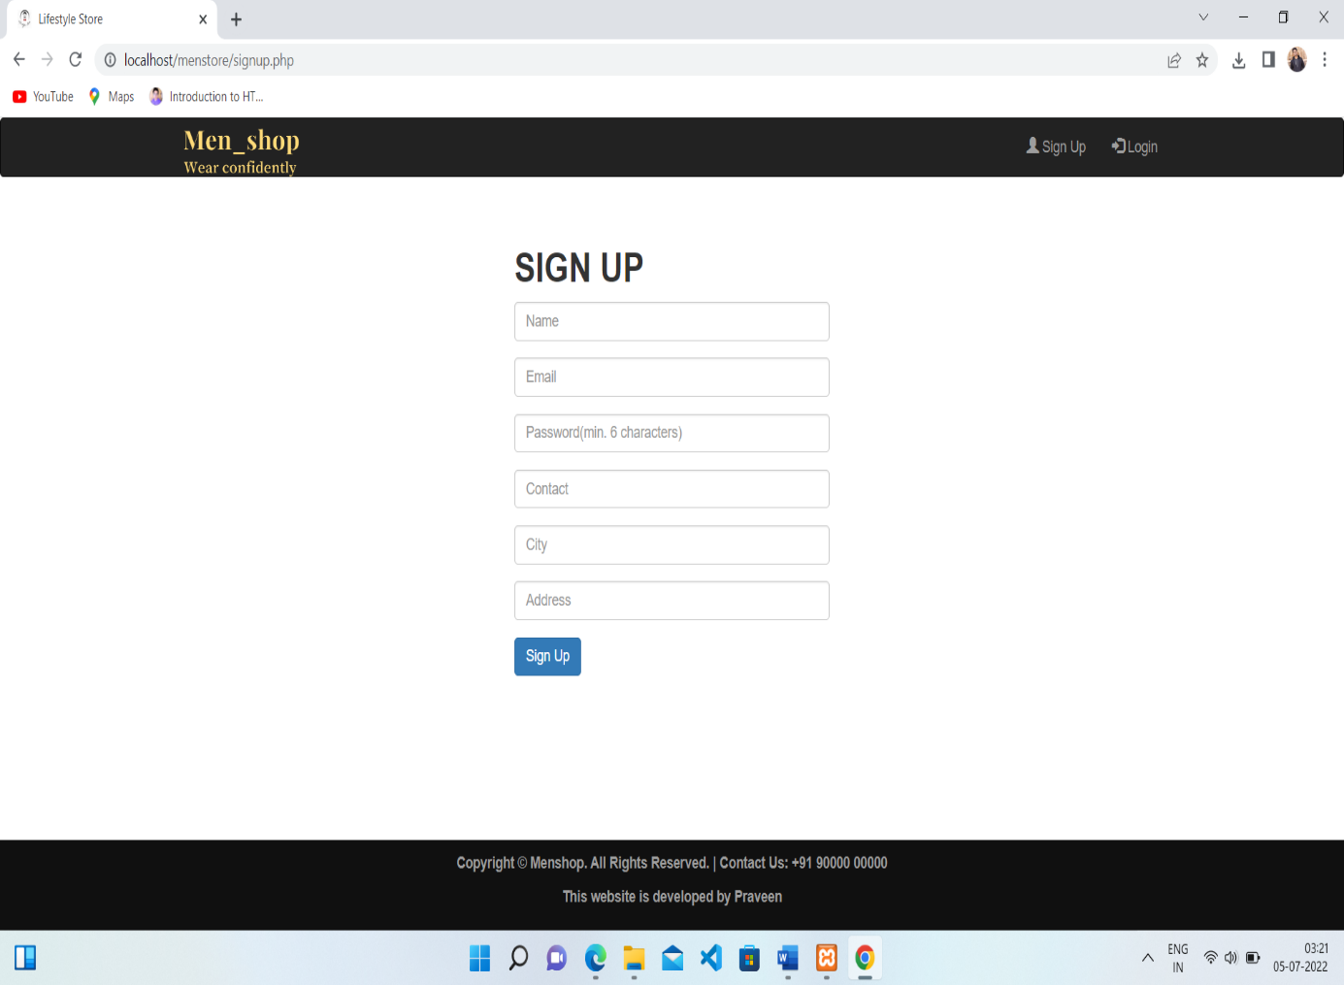

**LOGIN PAGE**

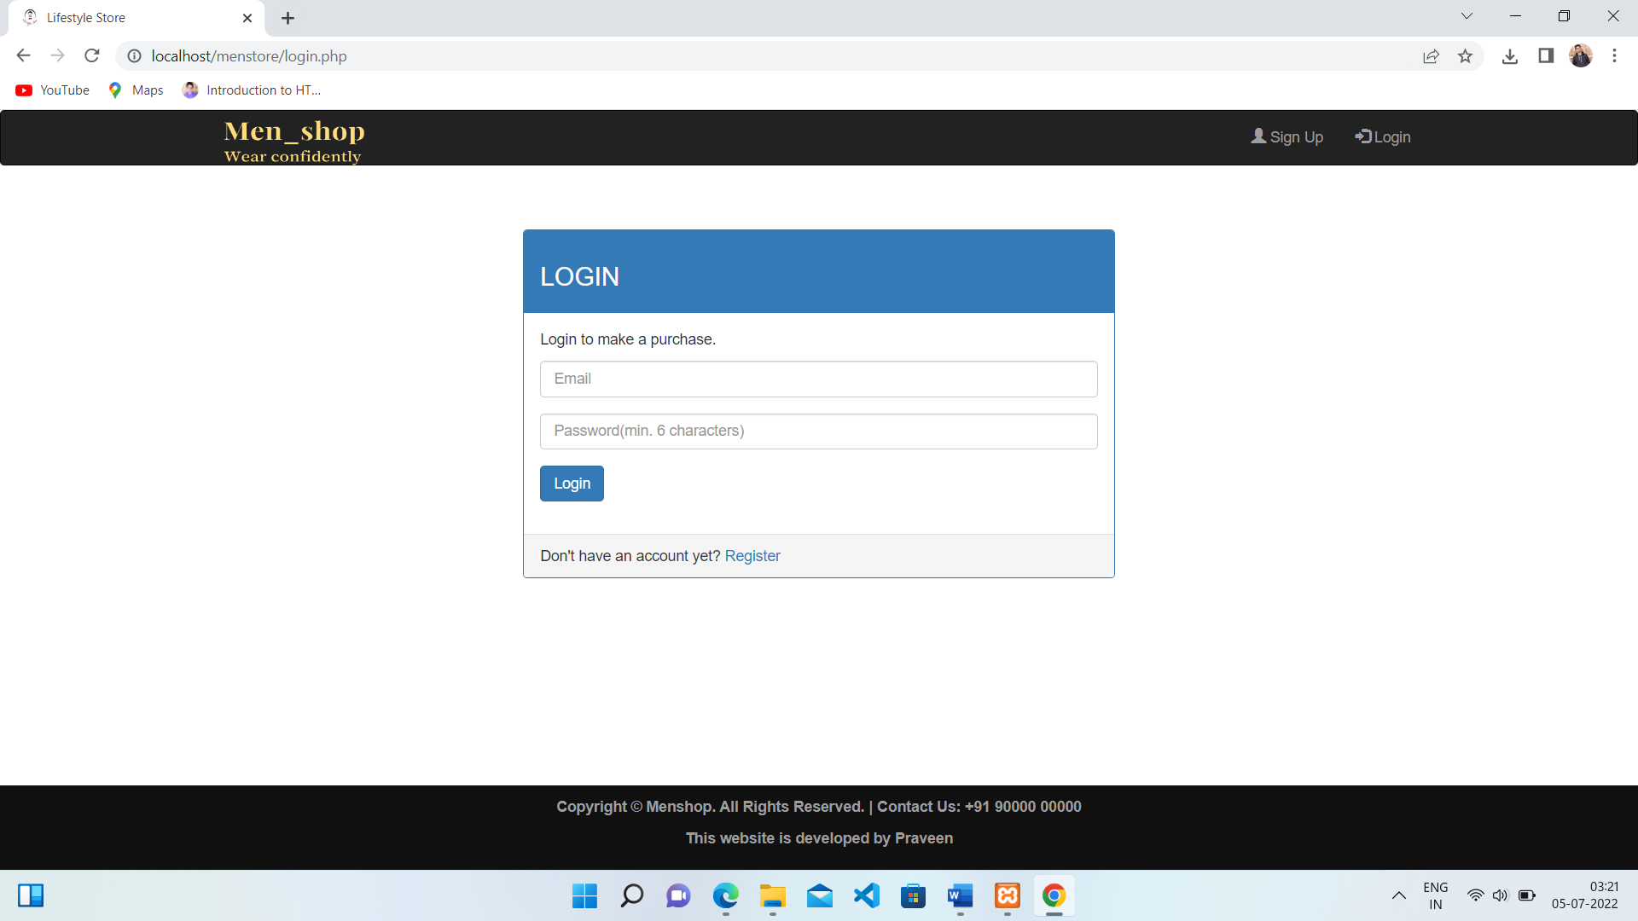

**PRODUCT PAGE**

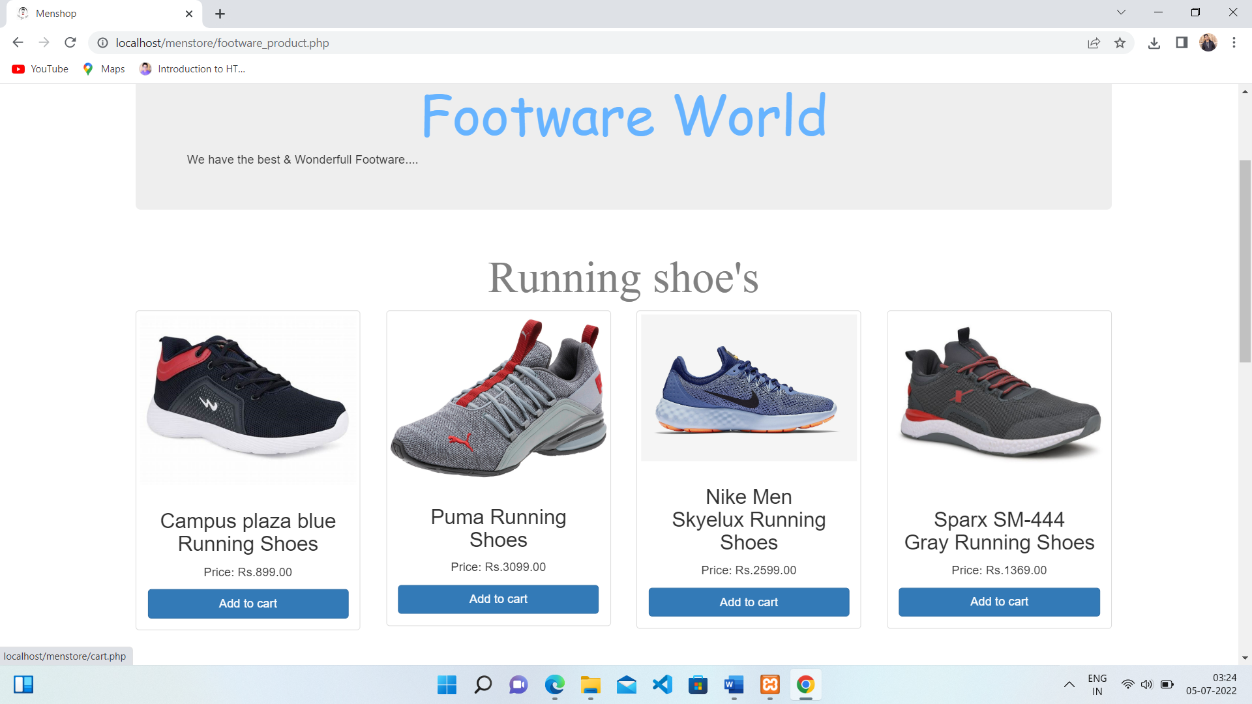

**PRODUCT PAGE**

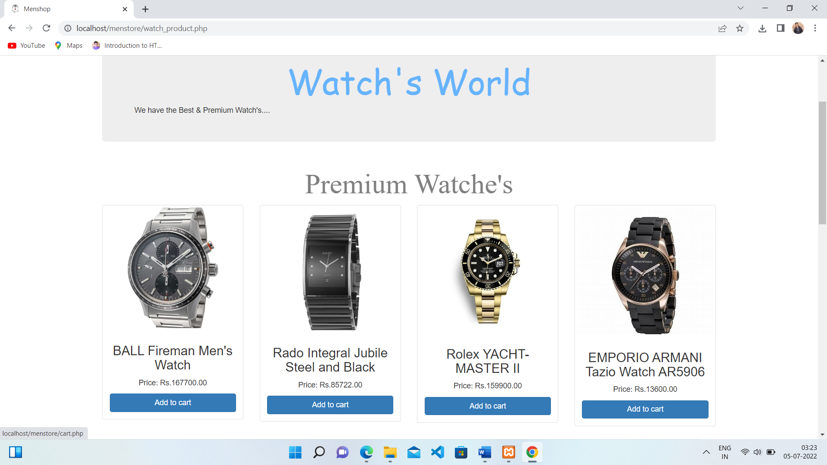

**PRODUCT PAGE**

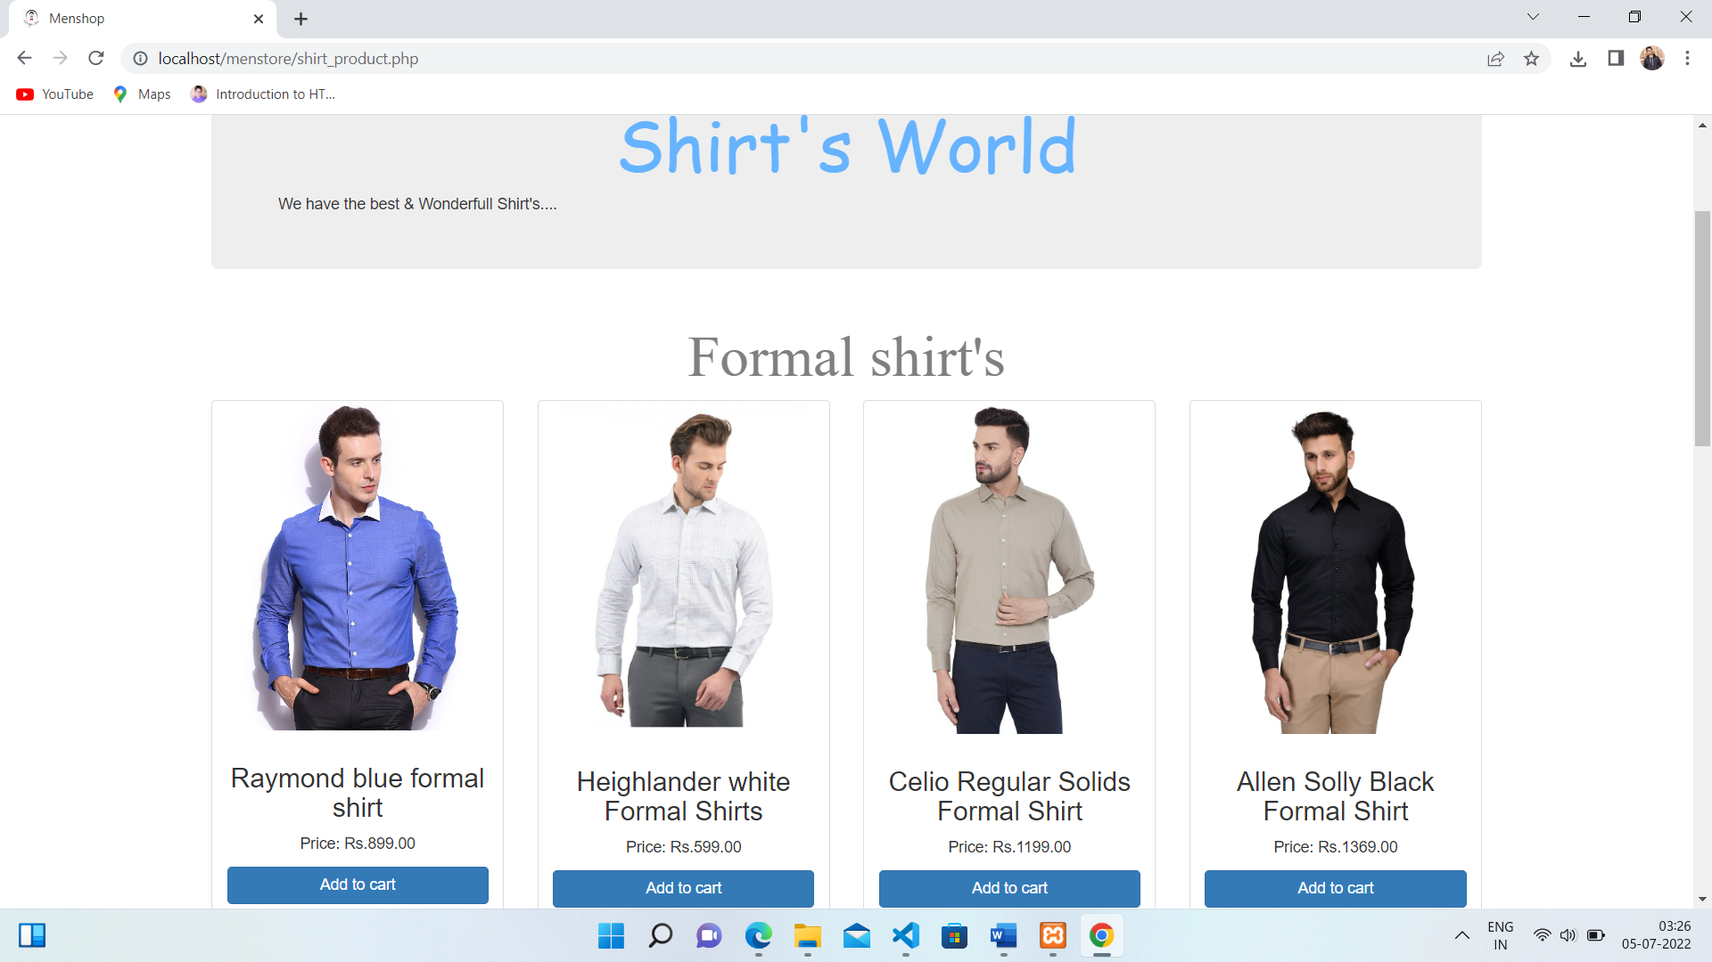

**CART PAGE**

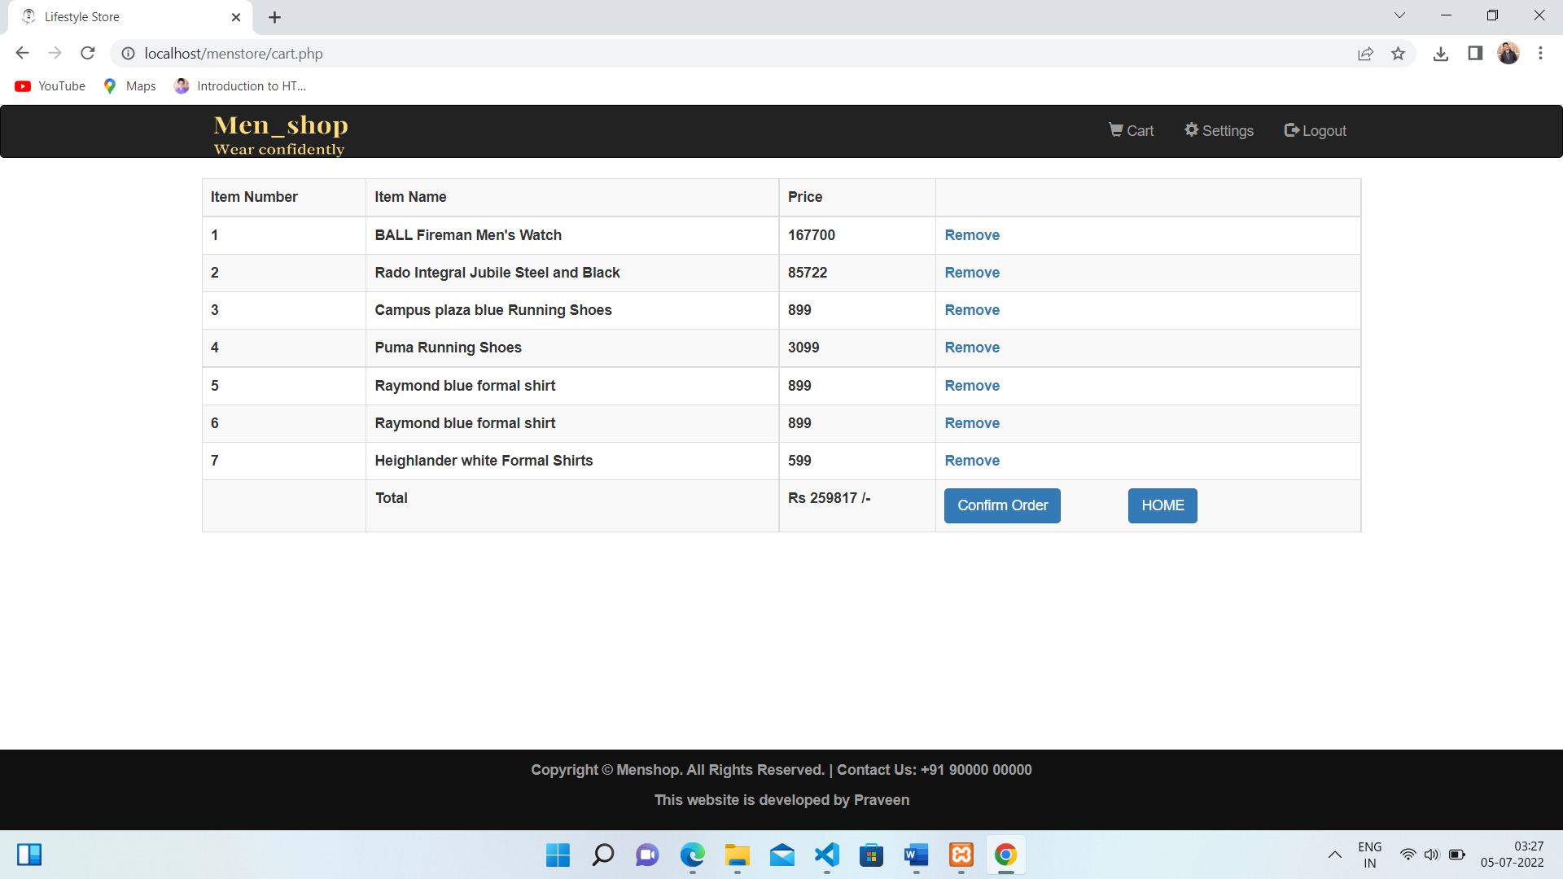

**ORDER CONFIRMED PAGE**

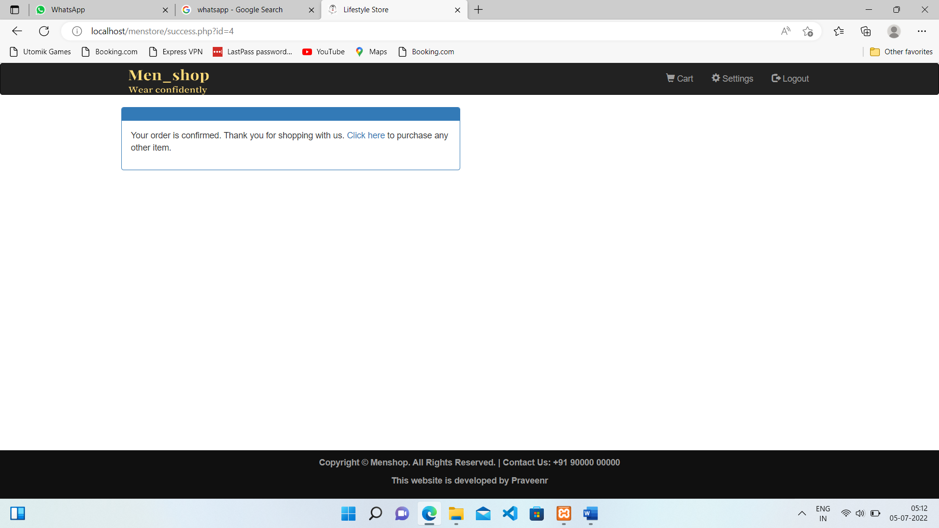

**DATABASE SCREEN SHOTS:**

**PRODUCT DATABASE**

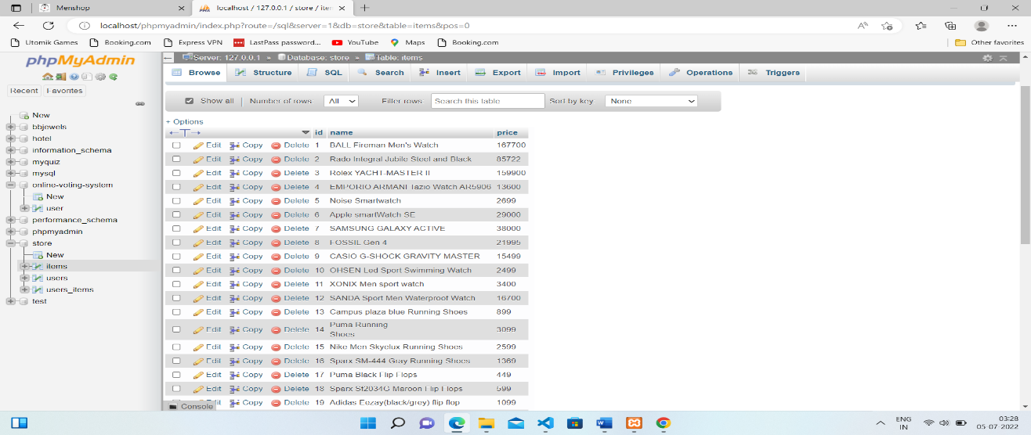

**USER DATABASE**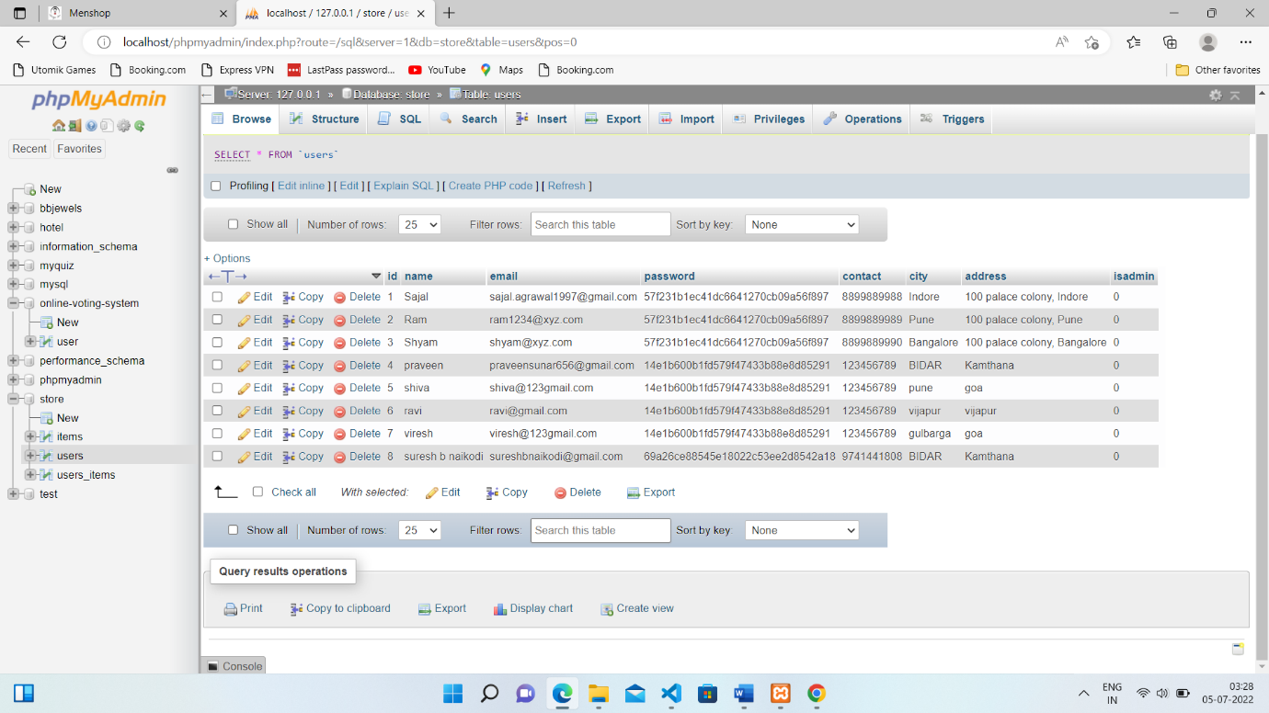

**USER ORDERED DATABASE**

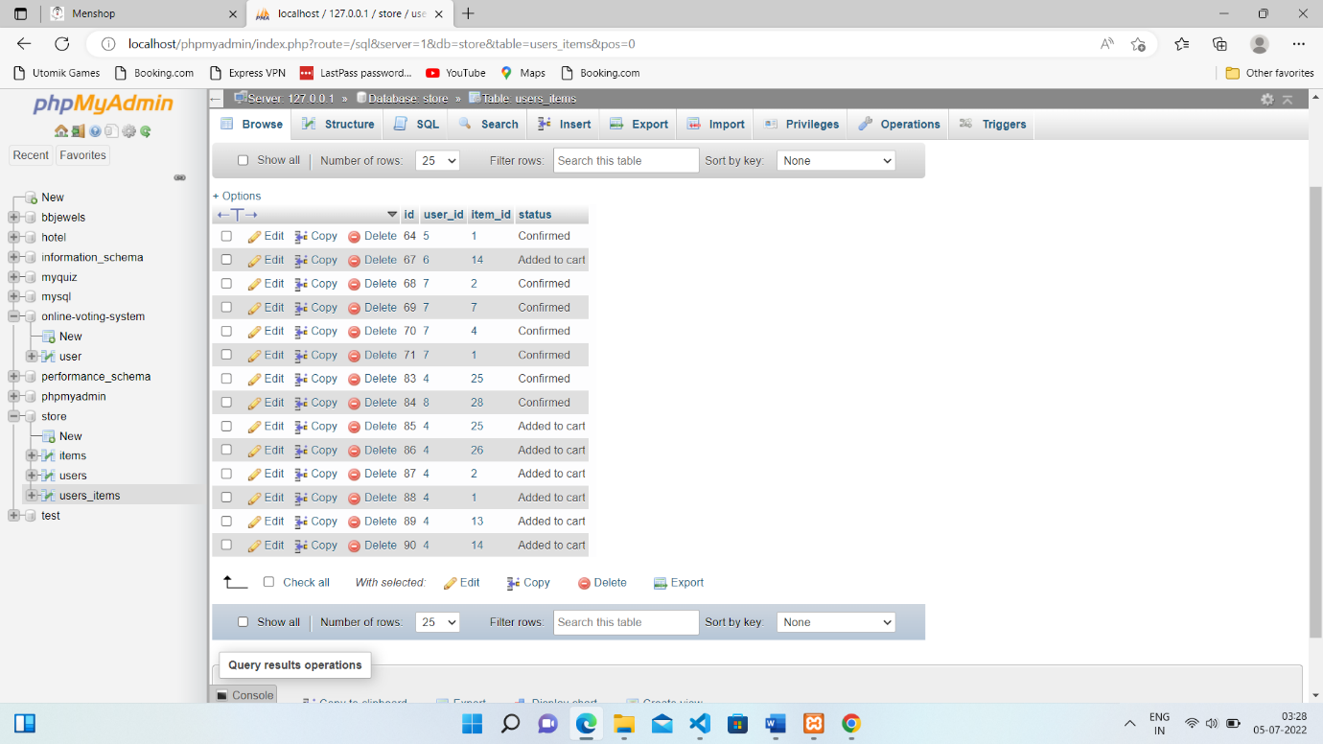

**DATABASE TABLES**

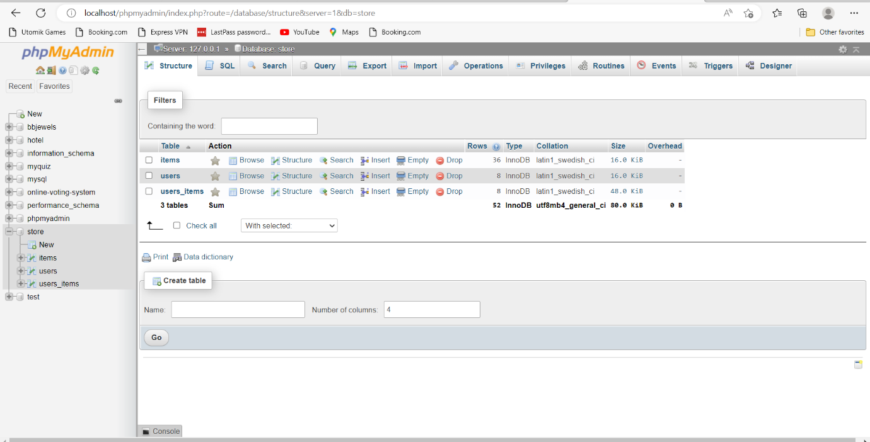

**6.SAMPLE CODE:**

PHP Code

**HOME PAGE**

<?php

session_start();

?>

<!DOCTYPE html>

<html>

    <head>

        <link rel="shortcut icon" href="img/lifestyleStore.png" />

        <title>Menshop</title>

        <meta charset="UTF-8">

        <meta name="viewport" content="width=device-width, initial-scale=1.0">

        <!-- latest compiled and minified CSS -->

        <link rel="stylesheet" href="bootstrap/css/bootstrap.min.css" type="text/css">

        <!-- jquery library -->

        <script type="text/javascript" src="bootstrap/js/jquery-3.2.1.min.js"></script>

        <!-- Latest compiled and minified javascript -->

        <script type="text/javascript" src="bootstrap/js/bootstrap.min.js"></script>

        <!-- External CSS -->

        <link rel="stylesheet" href="css/style.css" type="text/css">

    </head>

    <body>

        <div>

           <?php

            require 'header.php';

           ?>

           <div id="bannerImage">

               <div class="container">

                   <center>

                   <div id="bannerContent">

                       <h1  style="color:#ffffb3; font-family:cursive; font-size:30px">We sell MenFashion.</h1>

                       <p  style="color:#ccffcc; font-family:cursive; font-size:20px">Flat 30% OFF on all premium brands.</p>

                       <a href="#" class="btn btn-danger"><b>Shop Now</b></a>

                   </div>

                   </center>

               </div>

           </div>

           <div class="container">

               <div class="row">

                   <div class="col-xs-4">

                       <div  class="thumbnail">

                           <a href="footware_product.php">

                                <img src="img/footware.jpg" alt="Camera">

                           </a>

                           <center>

                                <div class="caption">

                                        <p id="autoResize">Footware</p>

                                        <p>Choose among the best available in the world.</p>

                                </div>

                           </center>

                       </div>

                   </div>

                   <div class="col-xs-4">

                       <div class="thumbnail">

                           <a href="watch_product.php">

                               <img src="img/watch1.jpg" alt="Watch">

                           </a>

                           <center>

                               <div class="caption">

                                    <p id="autoResize">Watch's</p>

                                    <p>Original watches from the best brands.</p>

                                </div>

                           </center>

                       </div>

                   </div>

                   <div class="col-xs-4">

                       <div class="thumbnail">

                           <a href="shirt_product.php">

                               <img src="img/shirts.jpg" alt="Shirt">

                           </a>

                           <center>

                               <div class="caption">

                                   <p id="autoResize">Shirt's</p>

                                   <p>Our exquisite collection of shirts.</p>

                               </div>

                           </center>

                       </div>

                   </div>

               </div>

           </div>

            <br><br> <br><br><br><br>

           <footer class="footer">

               <div class="container">

               <center>

                   <p>Copyright &copy Menshop. All Rights Reserved. | Contact Us: +91 90000 00000</p>

                   <p>This website is developed by Praveen</p>

               </center>

               </div>

           </footer>

        </div>

    </body>

</html>

**LOGIN PAGE**

<?php

  require 'connection.php';

    session_start();

?>

<!DOCTYPE html>

<html>

    <head>

        <link rel="shortcut icon" href="img/lifestyleStore.png" />

        <title>Lifestyle Store</title>

        <meta charset="UTF-8">

        <meta name="viewport" content="width=device-width, initial-scale=1.0">

        <!-- latest compiled and minified CSS -->

        <link rel="stylesheet" href="bootstrap/css/bootstrap.min.css" type="text/css">

        <!-- jquery library -->

        <script type="text/javascript" src="bootstrap/js/jquery-3.2.1.min.js"></script>

        <!-- Latest compiled and minified javascript -->

        <script type="text/javascript" src="bootstrap/js/bootstrap.min.js"></script>

        <!-- External CSS -->

        <link rel="stylesheet" href="css/style.css" type="text/css">

    </head>

    <body>

        <div>

            <?php

                require 'header.php';

            ?>

           <div class="container">

                <div class="row">

                    <div class="col-xs-6 col-xs-offset-3">

                        <div class="panel panel-primary">

                            <div class="panel-heading">

                                <h3>LOGIN</h3>

                            </div>

                            <div class="panel-body">

                                <p>Login to make a purchase.</p>

                                <form method="post" action="login_submit.php">

                                    <div class="form-group">

                                        <input type="email" class="form-control" name="email" placeholder="Email" pattern="[a-z0-9._%+-]+@[a-z0-9.-]+\.[a-z]{2,3}$">

                                    </div>

                                    <div class="form-group">

                                        <input type="password" class="form-control" name="password" placeholder="Password(min. 6 characters)" pattern=".{6,}">

                                    </div>

                                    <div class="form-group">

                                        <input type="submit" value="Login" class="btn btn primary">

                                    </div>

                                </form>

                            </div>

                            <div class="panel-footer">Don't have an account yet? <a href="signup.php">Register</a></div>

                        </div>

                    </div>

                </div>

           </div>

        </div>

    </body>

</html>

**SIGNUP PAGE**

<?php

    require 'connection.php';

    session_start();

    if(isset($_SESSION['email'])){

        header('location: products.php');

    }

?>

<!DOCTYPE html>

<html>

    <head>

        <link rel="shortcut icon" href="img/lifestyleStore.png" />

        <title>Lifestyle Store</title>

        <meta charset="UTF-8">

        <meta name="viewport" content="width=device-width, initial-scale=1.0">

        <!-- latest compiled and minified CSS -->

        <link rel="stylesheet" href="bootstrap/css/bootstrap.min.css" type="text/css">

        <!-- jquery library -->

        <script type="text/javascript" src="bootstrap/js/jquery-3.2.1.min.js"></script>

        <!-- Latest compiled and minified javascript -->

        <script type="text/javascript" src="bootstrap/js/bootstrap.min.js"></script>

        <!-- External CSS -->

        <link rel="stylesheet" href="css/style.css" type="text/css">

    </head>

    <body>

        <div>

            <?php

                require 'header.php';

            ?

            <div class="container">

                <div class="row">

                    <div class="col-xs-4 col-xs-offset-4">

                        <h1><b>SIGN UP</b></h1>

                        <form method="post" action="user_registration_script.php">

                            <div class="form-group">

                                <input type="text" class="form-control" name="name" placeholder="Name" required="true">

                          </div>

                            <div class="form-group">

                                <input type="email" class="form-control" name="email" placeholder="Email" required="true" pattern="[a-z0-9._%+-]+@[a-z0-9.-]+\.[a-z]{2,3}$">

                            </div>

                            <div class="form-group">

                                <input type="password" class="form-control" name="password" placeholder="Password(min. 6 characters)" required="true" pattern=".{6,}">

                            </div>

                            <div class="form-group">

                                <input type="tel" class="form-control" name="contact" placeholder="Contact" required="true">

                            </div>

                            <div class="form-group">

    <input type="text" class="form-control" name="city" placeholder="City" required="true">

                            </div>

                            <div class="form-group">

                                <input type="text" class="form-control" name="address" placeholder="full Address" required="true">

                            </div>

                            <div class="form-group">

                                <input type="text" class="form-control" name="pincode" placeholder="Pin code" required="true">

                            </div>

                            <div class="form-group">

                                <input type="submit" class="btn btn-primary" value="Sign Up">

                            </div>

                        </form>

                    </div>

                </div>

            </div>

**ADD CART PAGE**

<?php

    require 'connection.php';

    //require 'header.php';

    session_start();

    $item_id=$_GET['id'];

    $user_id=$_SESSION['id'];

    $add_to_cart_query="insert into users_items(user_id,item_id,status) values ('$user_id','$item_id','Added to cart')";

    $add_to_cart_result=mysqli_query($con,$add_to_cart_query) or die(mysqli_error($con));

    header('location: footware_product.php');

?>

**7.SYSTEM TESTING**

**7.1 INTRODUCTION**

Software testing is a critical element of software quality assurance and represents the ultimate review of specification, design and coding. In fact, testing is the one step in the software engineering process that could be viewed as destructive rather than constructive.

A strategy for software testing integrates software test case design methods into a well-planned series of steps that result in the successful construction of software. Testing is the set of activities that can be planned in advance and conducted systematically. The underlying motivation of program testing is to affirm software quality with methods that can economically and effectively apply to both strategic to both large and small-scale systems.

**STRATEGIC APPROACH TO SOFTWARE TESTING**

The software engineering process can be viewed as a spiral. Initially system engineering defines the role of software and leads to software requirement analysis where the information domain, functions, behavior, performance, constraints and validation criteria for software are established. Moving inward along the spiral, we come to design and finally to coding. To develop computer software we spiral in along streamlines that decrease the level of abstraction on each turn.

A strategy for software testing may also be viewed in the context of the spiral. Unit testing begins at the vertex of the spiral and concentrates on each unit of the software as implemented in source code. Testing progress by moving outward along the spiral to integration testing, where the focus is on the design and the construction of the software architecture. Talking another turn on outward on the spiral we encounter validation testing where requirements established as part of software requirements analysis are validated against the software that has been constructed. Finally we arrive at system testing, where the software and other system elements are tested as a whole.

UNIT TESTING

MODULE TESTING

SUB-SYSTEM TESING

SYSTEM TESTING

ACCEPTANCE TESTING

Component Testing

Integration Testing

User Testing

**Fig: System Testing**

**UNIT TESTING**

Unit testing focuses verification effort on the smallest unit of software design, the module. The unit testing we have is white box oriented and some modules the steps are conducted in parallel.

**1. WHITE BOX TESTING**

This type of testing ensures that

* All independent paths have been exercised at least once
* All logical decisions have been exercised on their true and false sides
* All loops are executed at their boundaries and within their operational bounds
* All internal data structures have been exercised to assure their validity.

To follow the concept of white box testing we have tested each form .we have created independently to verify that Data flow is correct, All conditions are exercised to check their validity, All loops are executed on their boundaries.

**2. BASIC PATH TESTING**

Established technique of flow graph with Cyclamate complexity was used to derive test cases for all the functions. The main steps in deriving test cases were:

Use the design of the code and draw correspondent flow graph.

Determine the Cyclamate complexity of resultant flow graph, using formula:

V(G)=E-N+2 or

V(G)=P+1 or

V (G) =Number Of Regions

Where V (G) is Cyclomatic complexity,

E is the number of edges,

N is the number of flow graph nodes,

P is the number of predicate nodes.

**3. CONDITIONAL TESTING**

In this part of the testing each of the conditions were tested to both true and false aspects. And all the resulting paths were tested. So that each path that may be generate on particular condition is traced to uncover any possible errors.

**4. DATA FLOW TESTING**

This type of testing selects the path of the program according to the location of definition and use of variables. This kind of testing was used only when some local variable were declared. The *definition-use chain* method was used in this type of testing. These were particularly useful in nested statements.

**5. LOOP TESTING**

In this type of testing all the loops are tested to all the limits possible. The following exercise was adopted for all loops:

* All the loops were tested at their limits, just above them and just below them.
* All the loops were skipped at least once.
* For nested loops test the inner most loop first and then work outwards.
* For concatenated loops the values of dependent loops were set with the help of connected loop.
* Unstructured loops were resolved into nested loops or concatenated loops and tested as above.

**8.CONCLUSION**

The project entitled Online shopping Website was completed successfully. The system has been developed with much attention and free of errors and at the same time, it is effectual and less time consuming. The purpose of this project was to develop a web Site for purchasing items from a shop. This project helped us in gaining appreciated information and practical knowledge on numerous subjects like designing web pages using php ,html & css, usage of responsive templates and controlling of database using MySQL. The entire system is secured. Also the project helped us understanding about the development stages of a project and software development life cycle. We learned how to test diverse features of a project. This project has agreed us great satisfaction in having designed an application which can be implemented to any nearby shops or branded shops selling various kinds of products by simple modifications. There is a scope for further development in our project to a great extent. A number of features can be added to this scheme in future like providing moderator more control over products so that each moderator can conserve their own products. Another feature is to implement was providing classes for customers so that different offers can be given to each class. System may keep track of history of purchases of each customer and provide recommendations based on their history.

.

**9.BIBLIOGRAPHY**

1. <https://www.tutorialspoint.com/php/index.htm>
2. <https://youtu.be/1SnPKhCdlsU>
3. [Introduction · Bootstrap v4.5 (getbootstrap.com)](https://getbootstrap.com/docs/4.5/getting-started/introduction/)
4. [Learn JavaScript Tutorial - javatpoint](https://www.javatpoint.com/javascript-tutorial)
5. [CSS Tutorial (w3schools.com)](https://www.w3schools.com/Css/)`